Phase II: Brazil’s State of the Economy
Name
Institutional Affiliation

Phase II: Brazil’s State of the Economy
Introduction
Brazil is the biggest economy in the continent of South America. Also, Brazil is the 8th largest in the globe (Baer, 2001). The country experienced a period of rapid economic growth and development from 2000 to 2010, after approximately three decades with a small increase in the gross domestic product per capita growth was primarily because of the significant changes in the external economic conditions alongside the more minor but crucial changes in the orientation of Brazil's macroeconomic as well as microeconomic policies (Carmem Aparecida Feijó, 2015). The nation’s average gross domestic product (GDP) growth from 2004 to 2010 was 4.43 percent (International Monetary Fund, 2018), slightly more than double that experienced from 1995 to 2003 period. But, the average GDP growth rate of the 2011-2014 period increasingly declined substantively to 2.12 percent (International Monetary Fund, 2018). The purpose of this essay is to discuss Brazil’s economic indicators such as GDP, unemployment, inflation, export and imports, and income growth.
Brazilian Economy Overview
Brazil is the largest economy in Latin America and 8th in the globe. However, the country is struggling for recovery from the 2015-2016 economic recession, which is the worst moment in the history of Brazil. The decrease in prices of Brazilian products reduced investments and export incomes, which eventually weakened the country’s real income as well as reduced primary sources of revenues such as taxation (Focaccia, 2005). The lower revenues from tax enormously affected the government budget. Additionally, weak real income made the country’s public debt that was majorly dominated in the United States currency expensive.
In 2016, the Brazilian government proposed various economic reforms and policies, aimed to reduce the rate of government spending as well as remove stumbling blocks to foreign investment. Increase in government expenditure resulted in the rise in the public debt from 50 percent of the gross domestic product in 2012 to 78 percent of GDP in 2017 (International Monetary Fund, 2018). The government policies and reforms to strengthen the country’s industrial sector as well as its workforce, like the emphasis on local content, might have increased emplacement levels at the expense of foreign investment.
The Brazilian economy has also been negatively affected by numerous graft scandals involving government officials and private business organizations. Sanctions against different companies involved have immensely limited their opportunities, thus establishing the ripple effect on the associated contractors and businesses. Also, the investment levels in these business corporations have increasingly decreased due to corruption scandals (Carmem Aparecida Feijó, 2015).
Brazil is also a member of various trade blocs such as Mercosur (Common Market of the South) which includes countries like Venezuela, Uruguay, Paraguay, and Argentina. After Russian as well as the Asian economic crisis, Mercosur imposed protectionism measures on non-members countries to protect its members against the exposure to foreign market volatilities. The protectionism tools have reduced foreign investment in the Brazilian economy.
Economic Indicators
Gross Domestic Product (GDP)
Brazilian is the 8th largest economy in the globe. After nearly ten years of strong economic growth during the 2002-2013 period, Brazil experienced the worst economic recession in the year 2015 with -3.76 percent of the gross domestic product and 2016 with -3.6 percent of GDP (International Monetary Fund, 2018). Recession occurred because of the drop in commodity prices as well as a fall of investment and consumption. However, in 2017, the Brazilian economy recovered, and its GDP increased by 1% (International Monetary Fund,2018). Various favorable macroeconomic and microeconomic conditions, as well as appropriate budgetary adjustments, have enhanced the country's economic recovery. Additionally, the Brazilian economy confirmed its rebound and restoration in 2018, and its gross domestic product increased by approximately 1.47 percent. Also, the Brazilian economy is anticipated to continue growing in 2020, reaching an estimation of the yearly gross domestic product growth rate of 2.5 percent (Carmem Aparecida Feijó, 2015).
Inflation Rate
The inflation rate increased slightly, reaching 3.8 percent compared to 3.3 percent in 2017 and is anticipated to reach 4.3 percent by the end of 2019 (Carmem Aparecida Feijó, 2015). Fiscal consolidation is the primary objective of the Brazilian government; although the budgetary deficit is anticipated to decline by the end of 2019, the Brazilian has promised the citizens to lower the imbalances to zero. On the other hand, the budget balance of the government in 2018 recorded a deficit of 7.4 percent which government wants to maintain at the same level for a period of 2019-2020 (International Monetary Fund,2018). The Brazilian government also focuses on the establishment of various social security policies and reforms but was not passed at the Congress.Additionally, if the government does not address multiple social security issues such as pension system policies and reform, it is likely to imperil the momentum of the economic growth and development, but the Brazil Congress is often far from enacting the reforms into law. The Central Bank of Brazil started the cycle of the interest rate rises in the period 2010-2011, increasing the nominal interest rates from 7.5 percent to 13.5 percent (International Monetary Fund, 2018)
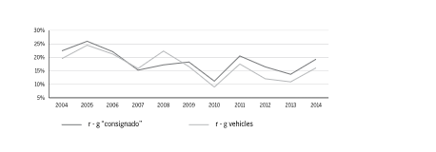
Figure 1: Differences between disposable income and interest rates (Focacci, 2005)

Level of Unemployment
The rate of unemployment in Brazil is very high compared to developed countries such as the United States, China, Japan, and the United Kingdom. In 2018 the rate of unemployment reached 11.87 percent, but the nation registered a 1% decline from 2017(International Monetary Fund, 2018). The continuous reduction of the unemployment rate all through 2018 increased household consumption. Even if the rate of unemployment decreased increasingly, Brazil still continuously experiencing different social issues as well as face the highest income inequality levels in the globe. Although the Brazilian governments have helped over twenty-nine million Brazilians out of abject poverty in the last two decades, more than 10 percent of Brazilians still live below the poverty line (Carmem Aparecida Feijó, 2015). Also, the wealthiest 5 percent in the country have a similar level of income with remaining people 95 percent.
Further, there are vast inequalities between regions, as well as currently the rate of criminal violence and delinquency has become increasingly high. Additionally, Rio de Janeiro’s indebtedness has had adverse effects on the country’s economy (Baer, 2001). The level of criminal violence increased over three years in Rio de Janeiro, which was mitigated by the formation of the controversial military in 2018.
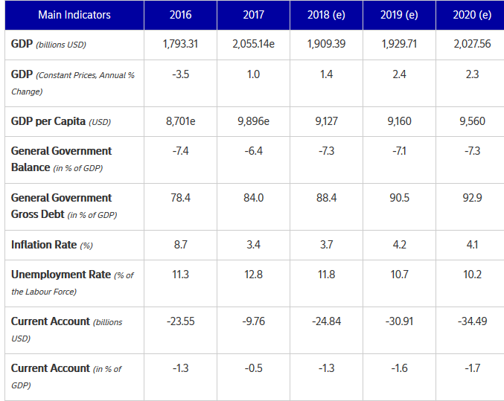
Figure 2: Economic indicators (International Monetary Fund, 2018)

Exports and Imports
Brazil is among the twenty-five largest importers and exporters in the world. International trade usually represents approximately 24.2 percent of Brazil's GDP. Brazil often has considerable economic potentiality. The country primarily imports, electronic and electrical commodities, pharmaceuticals and chemicals, vehicles, and hydrocarbons and exports air and oil vehicles minerals, and food products such as meat, maize, sugar, coffee, and soya beans. The nation’s main exports include motor vehicles (3.10 percent), sucrose and beet or cane sugar (5.20 percent), petroleum products (7.61%), iron ores (8.80 percent), and soya beans (11.80 percent).On the other hand, Brazil’s main imports include pharmaceuticals and chemicals (2.1 percent), coal (2.3 percent), electronics and electrical products (2.8 percent), accessories and parts for motor vehicles and tractors (3.6 percent), and petroleum goods( 7.90 percent) (Carmem Aparecida Feijó, 2015).
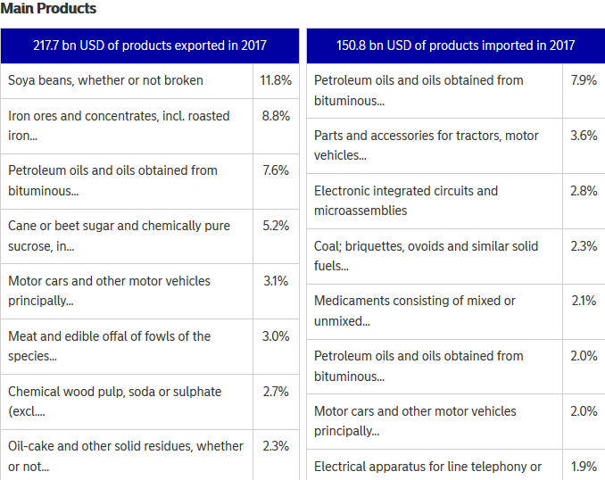
Figure 3: Brazil’s main products (International Monetary Fund, 2018)
Brazil's main partners in trade are countries of the European Union and Mercosur, Japan, the US, and China. Despite Brazil being the eighth in the globe and largest in South America, the country closed than other developed countries, with low volumes of exports relative to its population as well as low commercial penetration (Baer, 2001).
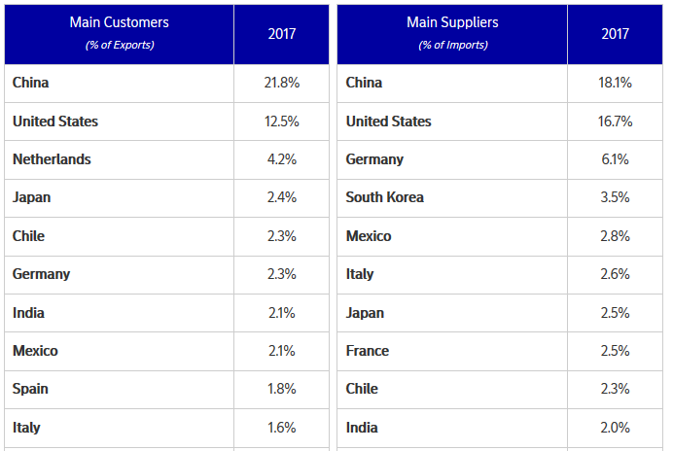
Figure 4: Brazil’s main trade partners
Brazil’s Balance of Trade
The balance of trade of Brazil is relatively positively but has been decreasing annually because of the increase in the import of energy products, decrease in prices of various raw materials, as well as due to drop in the competitiveness of the products produced by the Brazilians (Baer, 2001).
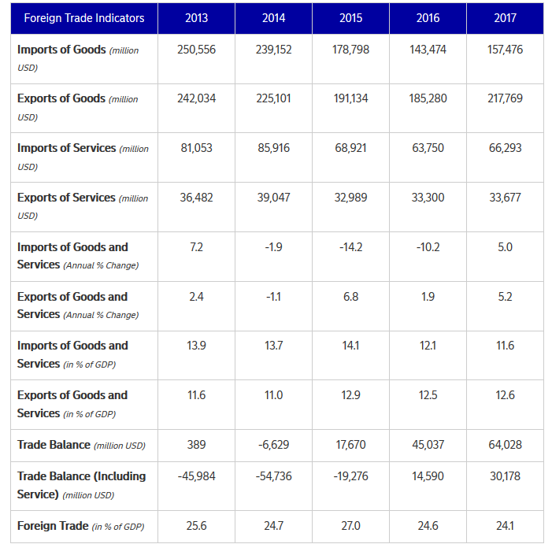
Figure 4: Exports and imports indicators (International Monetary Fund,2018)

References
Baer, W., (2001). Brazilian Economy, The: Growth and Development. ABC-CLIO. Retrieved 6 1, 2019, from https://books.google.co.ke/books?hl=en&lr=&id=2NAP2Xp1DnEC&oi=fnd&pg=PR5&dq=Brazilian+economy+status+&ots=5_m6sxi2WO&sig=OWvRcBuZJzuMo_QHY7H3gSI0pXs&redir_esc=y#v=onepage&q=Brazilian%20economy%20status&f=false
Carmem Aparecida Feijó, M. T. (2015). Accumulation pattern of the Brazilian economy in the 1990s and 2000s. International Review of Applied Economics, 29(1), 15-31. doi: 10.1080/02692171.2014.933787
Focacci, A., (2005). The empirical analysis of the environmental and energy policies in some developing countries using widely employed macroeconomic indicators: the cases of Brazil, China, and India. Energy Policy, 33(4), 543-554. Retrieved from https://www.sciencedirect.com/science/article/pii/S0301421503002611
International Monetary Fund, (2018). World Economic Outlook, October 2018: Challenges to Steady Growth. International Monetary Fund,2018.

